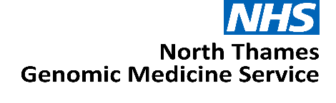

Expression of Interest:

Pathology Medical Lead

North Thames Genomic Medicine Service

JOB TITLE: Pathology Medical Lead

AREA/SPECIALITY: NHS North Thames Genomic Medicine Service (GMS)

GRADE: Consultant

COMMITMENT: 2PA (1 day per week)

TENURE: Salary recharge agreement from 1st April 2026 until 31st March 2029

BASE: Continue to be employed at host organisation with option to work
from the GOSH site, travel may be required within the North Thames
geography

RESPONSIBLE TO: NT GMS Medical Director

ACCOUNTABLE TO: NT GMS Medical Director

Role Summary
In conjunction with the Chief Operating Officer, the GMS and GMS Laboratory Leads, and the GMS Medical Directors, to advise on the strategic development and delivery of the Genomics service with respect to Cellular Pathology issues, integration and liaison; as part of a comprehensive, efficient and high quality integrated Genomics Medicine Service for the population of the North Thames geography.
To work with the newly commissioned CPGC to establish and develop their service, and to work with the remaining centres around continual service improvement and development.
To work with any tumour specific champions appointed as part of the extended Genomic Medicine Service to ensure engagement, pathway development including implementation of NGIS across the London North Geography.
To assist with the clinical engagement with service stakeholders for cancer throughout the geography helping to embed genomics as a standard element of the patient pathways across all relevant areas of care, demonstrating commitment to laboratory consolidation and delivery of a high quality, high throughput efficient service.
As a key member of the North Thames Senior Delivery Team, the postholder will work with the Senior Leadership Team to work on the delivery of GMS priorities related to Cellular Pathology.

Background

The NHS has a strong, long and pioneering history of using genetic medicine to help improve the lives of patients.
In 2018, the NHS England Genomics Unit set-out how it would achieve the forward-looking ambition to make England one of the first countries to incorporate genomics into routine clinical practice in our healthcare system. The solution, to create an opportunity for a step-change by launching a dedicated service – the Genomic Medicine Service (GMS).
The ambition was to make England one of the first countries to embed genomics into routine clinical care in a national healthcare system.
The establishment of the GMS aimed to bridge the gap between research and clinical care – shaping how genomics is advanced and applied within an NHS setting including for:
- Diagnostic testing
- Treatment decision
- Predictive testing
- Cancer testing
Through the GMS, 55 million people in England have access to consistent and fair genomic testing. The GMS is spilt into seven regional services, each region is responsible for delivering genomic testing, upskilling and educating the NHS workforce, participating in genomic research and working with the patient and public in re-designing clinical pathways across their population.
The NHS 10-Year Plan proposes a future where genomic or genetic interactions becomes part of routine healthcare, available to everyone in local communities playing a key part in the shift to Neighbourhood Health. This may include for example, screening all newborns to understand their future health needs or offering adults tests to spot the early signs of conditions like cancer or heart disease before symptoms appear. By identifying risks early, genomics can inform personalised treatments sooner and more effectively.
By 2035, NHS England estimate that up to half of all medical treatments or healthcare decisions will utilise genomics to improve patient care.
The North Thames Genomic Medicine Service

The North Thames Genomic Medicine Service (NT GMS) strives to provide an equitable genomic service for people living in North London and parts of Hertfordshire and Essex. We also provide cancer genomic testing for people living in Kingston, Merton, Richmond, Wandsworth and Sutton.
Across England the NT GMS is the second largest regional provider of genetic and genomic testing from the seven regions and delivers the largest volume of cancer genetic testing. The service also provides the largest portfolio of specialist rare and inherited disease genomic testing that is not provided by other GMS regions. We are also home to the only amyloidosis genetic testing facility in the UK.

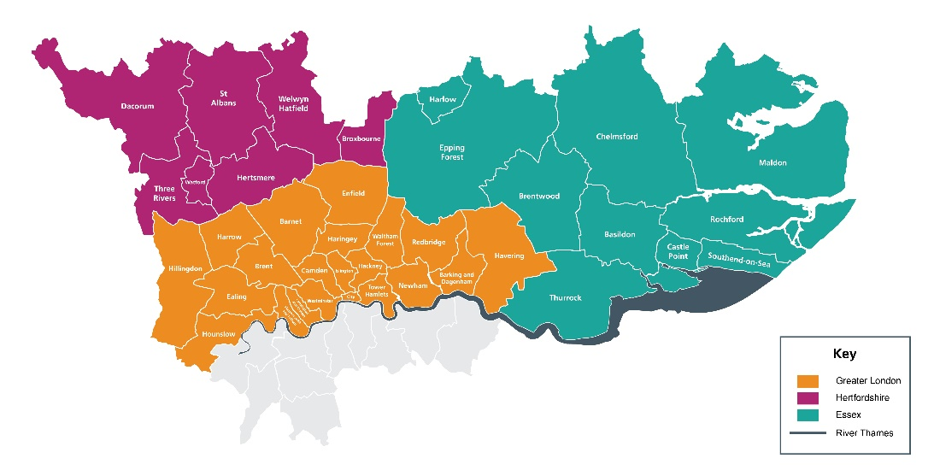

The NT GMS is a collaboration of multiple acute providers across North London. Hosted by Great Ormond Street Hospital NHS Foundation Trust (GOSH), led by GOSH and the Royal Marsden NHS Foundation Trust (RMH), the service brings together expertise from across the geography to deliver genomics services.
Our senior leadership team is led by Medical and Scientific Directors as well as a Chief Operating Officer and are supported by teams across cross-cutting laboratory and clinical workstreams. Our Patient, Public and Carer Panel feed into every aspect of the work in the NT GMS. Our strength across key areas: cancer, population health, rare and inherited disease, and research and innovation spans not only testing but clinical expertise and support from wider systems.

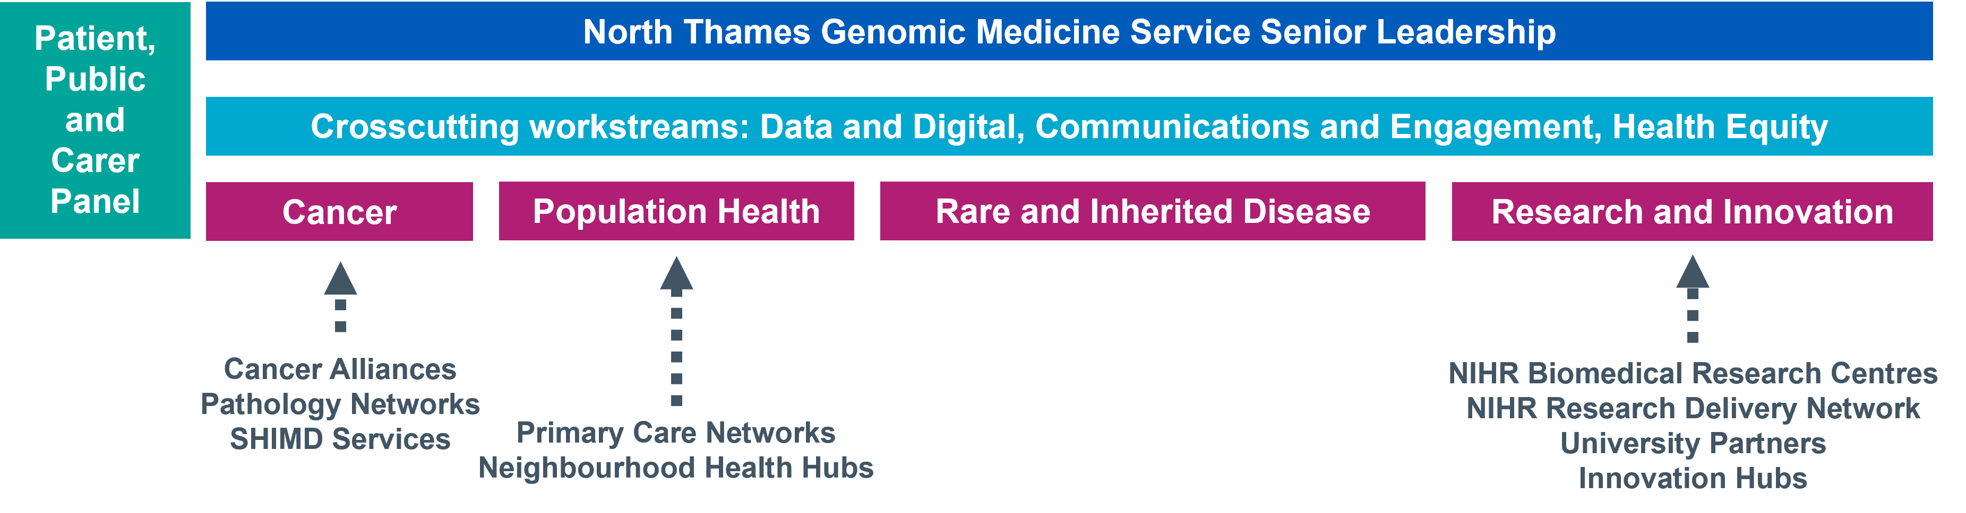
This expertise is spread across our geography, providing unique insights and local knowledge of not only specialist areas but also the population and community we serve. Through collaborations and knowledge sharing, we have built a team with expertise across all areas of genomics - from technology development, clinical integration, operational and programme management, education, social science, communications and engagement and health equity.
We believe our significant expertise puts us at the heart of delivering the genomics ambitions of the NHS and the 10 Year Plan that was published in 2025.
Main Roles & Responsibilities
Education, Training and Workforce Development
- Work closely with the NT GMS Education, Training and Workforce Lead to develop and deliver a sustainable genomic education and training strategy for the current and future multi-professional workforce across the region.

- Support delivery and reporting of Education and Training workstreams, ensuring alignment with NT GMS priorities, national governance requirements, and the GMS contract specification.
Clinical Pathways and Service Integration
- Raise awareness of genomic services across multidisciplinary teams and support pathway-based approaches to embedding genomics into patient journeys.

- Identify opportunities for and participate in service improvement and pathway transformation.

- Work across Cellular Pathology Genomic Centres to deliver high-quality, effective, and efficient routes to Genomic testing. This includes implementing new initiatives, and supporting with service improvement projects.

- Work closely with the NT GMS Informatics and Digital team to champion genomic data literacy and ensure adoption of digital genomic systems including electronic ordering and the Unified Genomic Record.

Population Health, Equity and Public Engagement
- Provide Cellular Pathology Genomics expertise to population-level genomic initiatives, including cascade testing, inherited cancer pathways, pharmacogenomics, and emerging polygenic risk score programmes.

- Work with the NT GMS Health Equity Lead to understand and address variation and unmet need in access to genomic testing.

- Collaborate with the Communications and Engagement Lead on patient and public involvement initiatives as required.

Governance, Leadership and Stakeholder Engagement
- Attend relevant meetings as directed by the NT GMS Leadership Team, providing written or verbal updates as required.

- Act as a key link between cellular pathology and the NT GMS, ensuring stakeholder representation and engagement in delivery of clinical genomic functions.

- Represent the NT GMS at regional and national meetings when appropriate.

- Work closely with key stakeholders across all levels, including NT GMS leadership, NHS Trusts across the region, the Genomics Education Programme (GEP), NHS England Genomics Unit, and Genomics England.

Working relationships

Internal
- GMS Senior Management and Delivery teams
- Laboratory leads and staff across the GMS
- North Thames Patient and Public Involvement panel
- Relevant Clinical teams in Trusts across the GMS
- Laboratory Leads and Pathology staff across the GMS
- Cellular Pathology Genomic Centres

External
- North Thames Trust boards, ICBs & ICSs across the GMS geography
- North Thames and National Nursing, Midwifery and Health Visitor networks
- NHS England Genomics Unit
- Public Health England
- Primary care services
- Other Genomic Medicine Services across England
- Primary Care services
- North Thames mainstream clinical services

Person Specification
Education & Qualifications | Essential or Desirable | Assessment method (Application/Interview)
Medical Consultant in Cellular Pathology | E | Application/Interview
Proven expertise in assessing and processing tissue for genomic testing | E | Application/Interview
Higher degree – PhD, MD or equivalent | D | Application
Leadership qualification | D | Application/Interview
Experience and abilities | Essential or Desirable | Assessment method (Application/Interview)
Demonstrable commitment to improving the quality of patient care using a whole system patient focused approach across organisational and/or geographical boundaries | E | Application/Interview
Experience of planning and improving quality of patient services | E | Application/Interview
A recognised national/international expert in own field as evidenced by publication record and in contributing to national and international initiatives in pathology and genomic science/medicine | E | Application/Interview
Awareness of the importance of Clinical Governance through experience of participating in quality or safety improvement projects | E | Application/Interview
Proven leadership of managing teams and leadership experience at department or divisional level | E | Application/Interview
Experience in working at a regional/national level (e.g. as a member of a committee) | D | Application/Interview
Experience of facilitating teaching or training sessions | D | Application/Interview
Knowledge and skills | Essential or Desirable | Assessment method (Application/Interview)
Understanding of professional and current issues related to genetics, the NHS, and relevant fields | E | Application/Interview
Proven ability to support and develop teams and individuals | E | Application/Interview
Successful change management skills | E | Application/Interview
Ability to prioritise and plan work effectively autonomously, providing specialist advice to the organisation | E | Application/Interview
Strong oral and written communication skills | E | Application/Interview
Ability to communicate complex information effectively, both verbally and in writing | E | Application/Interview
Ability to interpret complex information and to take appropriate action or provide expert advice as a result | E | Application/Interview
Excellent interpersonal and negotiating skills | E | Application/Interview
IT skills | E | Application
Terms and Conditions
This is a 1 day per week post with line management and supervision reporting into the NT Deputy Medical Director. The duration for the post is until 31st March 2029
The applicant should be working for an employer within the North Thames GMS geography and will remain employed with their substantive employer for the duration of this role.
Health & Safety
Employees must be aware of the responsibilities placed upon them under the Health & Safety at Work Act (1974), to ensure that the agreed procedures are carried out to maintain a safe environment for employees and visitors.

Data Protection
Personal data is protected under the Data Protection Act (2018) and the post holder will ensure that it is securely held and that the requirements of the Act are followed.

Confidentiality
The confidentiality of information relating to patients/clients and staff must be safeguarded at all times in accordance with the Information Security Policy. Disclosure to any unauthorised person or misuse or failure to properly safeguard confidential data will be regarded as a disciplinary offence.

Expression of Interest Form
Please email the completed form below and CV to sweta.karthikeyan@gosh.nhs.uk with the subject heading: GMS Pathology Lead

The deadline for submission is Tuesday 28th July 2026

- Applicant details
Name | Email address
Employer name | Job title

- Please tell us why you are interested in the Pathology Medical Lead role and the skills, experience and unique perspective you would bring to the team (maximum 1000 words).

- Finance
Please state your current AfC banding or current NHS salary
Applicant current agenda for change banding and/or NHS salary:

- Supporting statement from your senior manager
I can confirm my full support for the above applicant and agree to:
- Support the applicant to work within the role in the Genomic Medicine Service as described above
- Release the applicant from their current commitments for the proposed time

Name | Position
Telephone number | Email contact
Signature & Date

- Applicant CV
Please attach applicant CV (maximum of two pages) to the expression of interest submission.

