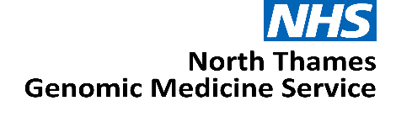

Expression of Interest:

Research and Innovation Clinical Leads (Cancer and Rare Disease)

North Thames Genomic Medicine Service

JOB TITLE: Research and Innovation Clinical Lead

AREA/SPECIALITY: NHS North Thames Genomic Medicine Service (GMS)

GRADE: Consultant

COMMITMENT: 2 PA’s (1 day per week) for each role

TENURE: Salary recharge agreement from 1st April 2026 until 31st March 2029

BASE: Continue to be employed at host organisation with option to work
from the GOSH site, travel maybe required within the North Thames
geography

RESPONSIBLE TO: NT GMS Deputy Medical Director (Rare Disease post) and NT GMS Medical Director (Cancer post)

Role Summary
We are seeking motivated and experienced clinicians with a strong interest in research and/or innovation to co-lead the North Thames Research and Innovation clinical function. The successful candidate will bring clinical and research credibility, collaborative leadership, and a clear commitment to driving continuous improvement of genomic medicine.

The North Thames GMS is looking to appoint two individuals at 2 PAs a week, one to lead the cancer research and innovation function and one to lead the equivalent role for rare disease.
The role will provide strategic leadership and operational oversight for all genomics‑related research and innovation across the NHS GMS geography working within the new Genomic Medicine Service specification which will support the ambitions of the NHS 10-Year Health Plan.

As a key member of the North Thames Senior Delivery Team, the postholder will work closely with the Senior Leadership Team to jointly lead the development and delivery of the Research and Innovation clinical function aligned to NHS GMS national direction, ensuring research opportunities, partnerships, and cutting‑edge technologies are fully embedded within clinical, laboratory and digital genomics services.

Background

The NHS has a strong, long and pioneering history of using genetic medicine to help improve the lives of patients.
In 2018, the NHS England Genomics Unit set out how it would achieve the forward-looking ambition to make England one of the first countries to incorporate genomics into routine clinical practice in our healthcare system. The solution, to create an opportunity for a step-change by launching a dedicated service – the Genomic Medicine Service (GMS).
The ambition was to make England one of the first countries to embed genomics into routine clinical care in a national healthcare system.
The establishment of the GMS aimed to bridge the gap between research and clinical care – shaping how genomics is advanced and applied within an NHS setting including for:
- Diagnostic testing
- Treatment decision
- Predictive testing
- Cancer testing
Through the GMS, 55 million people in England have access to consistent and fair genomic testing. The GMS is spilt into seven regional services, each region is responsible for delivering genomic testing, upskilling and educating the NHS workforce, participating in genomic research and working with the patient and public in re-designing clinical pathways across their population.
The NHS 10-Year Plan proposes a future where genomic or genetic interactions becomes part of routine healthcare, available to everyone in local communities playing a key part in the shift to Neighbourhood Health. This may include for example, screening all newborns to understand their future health needs or offering adults tests to spot the early signs of conditions like cancer or heart disease before symptoms appear. By identifying risks early, genomics can inform personalised treatments sooner and more effectively.
By 2035, NHS England estimate that up to half of all medical treatments or healthcare decisions will utilise genomics to improve patient care.
The North Thames Genomic Medicine Service

The North Thames Genomic Medicine Service (NT GMS) strives to provide an equitable genomic service for people living in North London and parts of Hertfordshire and Essex. We also provide cancer genomic testing for people living in Kingston, Merton, Richmond, Wandsworth and Sutton.
Across England the NT GMS is the second largest regional provider of genetic and genomic testing from the seven regions and delivers the largest volume of cancer genetic testing. The service also provides the largest portfolio of specialist rare and inherited disease genomic testing that is not provided by other GMS regions. We are also home to the only amyloidosis genetic testing facility in the UK.

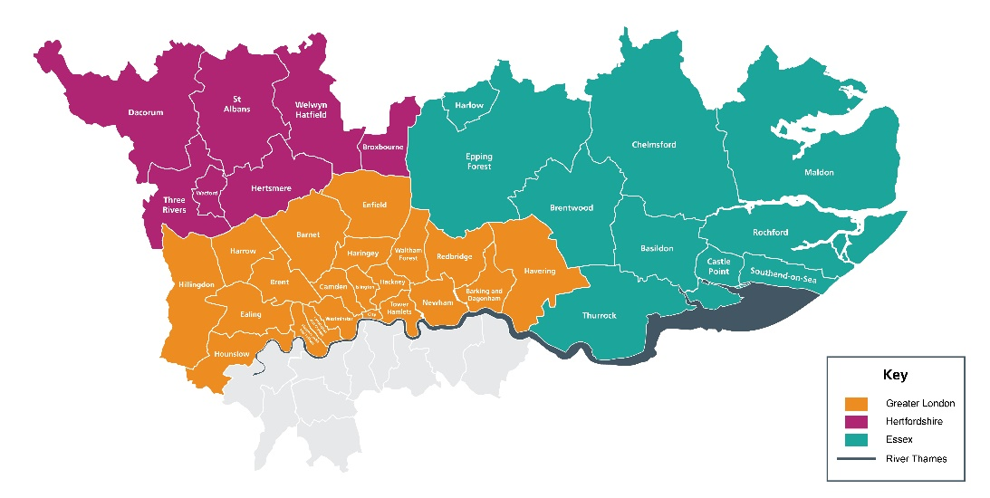

The NT GMS is a collaboration of multiple acute providers across North London. Hosted by Great Ormond Street Hospital NHS Foundation Trust (GOSH), led by GOSH and the Royal Marsden NHS Foundation Trust (RMH), the service brings together expertise from across the geography to deliver genomics services.
Our senior leadership team is led by Medical and Scientific Directors as well as a Chief Operating Officer and are supported by teams across cross-cutting laboratory and clinical workstreams. Our Patient, Public and Carer Panel feed into every aspect of the work in the NT GMS. Our strength across key areas: cancer, population health, rare and inherited disease, and research and innovation spans not only testing but clinical expertise and support from wider systems.

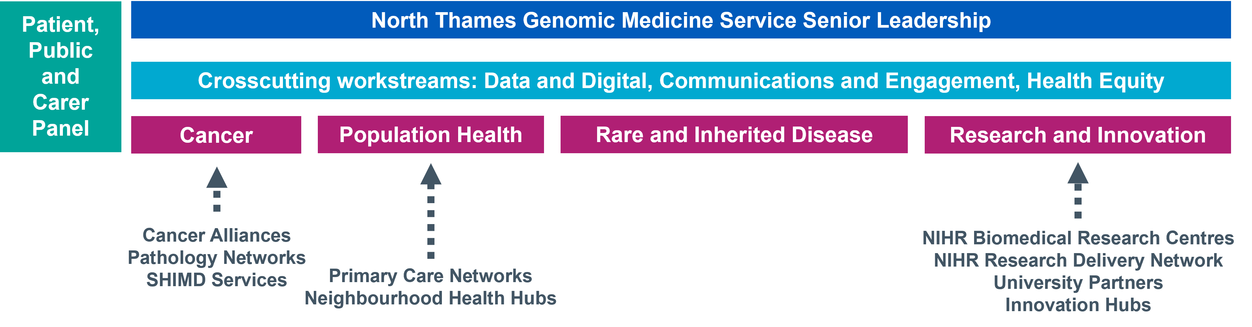
This expertise is spread across our geography, providing unique insights and local knowledge of not only specialist areas but also the population and community we serve. Through collaborations and knowledge sharing, we have built a team with expertise across all areas of genomics - from technology development, clinical integration, operational and programme management, education, social science, communications and engagement and health equity.
We believe our significant expertise puts us at the heart of delivering the genomics ambitions of the NHS and the 10 Year Plan that was published in 2025.
Main Roles & Responsibilities
Strategy and Leadership
- Lead the development and delivery of the Research and Innovation enabling function, including setting local research priorities, aligned to NHS GMS national direction.

- Develop and implement a North Thames Genomic Research Strategy supporting regional priorities and national commitments in the NHS 10 Year Health Plan; The Life Sciences Sector Plan and the UK Rare Disease Framework

- Provide leadership for the Genomics Research and Innovation agenda across cancer, rare disease, population health and pharmacogenomics.
Project and Transformation delivery
- Lead implementation of research outputs into clinical practice, ensuring rapid and safe adoption across the geography.

- Drive horizon scanning and translation of scientific advances into service delivery.

- Working with the NT GMS Transformation Lead, contribute to delivery of Genomic Networks of Excellence where appropriate.

- Work with research networks, trials units and industry to increase participation in: -

- Genomically-stratified clinical trials
- National priority programmes (e.g., Generation Study, Adult Genome Population Study)
- Advanced therapeutics trials (ATMPs)

- Oversee pathways for identification, referral and enrolment of eligible patients into trials, ensuring alignment with routine genomic testing.

- Support the development and use of consented datasets, including contributions to the National Genomic Research Library.

- Lead work to ensure data from clinical trials is accessible and integrated into clinical learning systems.

- Champion use of federated data environments, AI models and genomic knowledge bases to accelerate research and implementation.

- Working with the NT Informatics and Data team, support digital consent evolution, including research choices integrated with genomic testing pathways.

- Work with the NT GMS Communications and Engagement lead on patient and public involvement projects as required.

Education, Training & Workforce Development
- Build research and innovation capability across clinical, scientific and operational teams.

- Provide education and mentorship to embed a culture of research and innovation across the NHS GMS geography.

- Support pathways for training, fellowships and translational research roles.

Governance and Stakeholder Engagement
- Attend relevant meetings as directed by the NT GMS Leadership Team, providing written or verbal updates as required.
- Report progress against GMS deliverables for impact, outcomes and progress against agreed research priorities in line with the NT GMS and national governance reporting frameworks and GMS contract specification.

- Develop and maintain high-impact partnerships with Genomics England; NIHR infrastructure; Health Data Research Service; Health Innovation Networks (UCLP and ICHP); Academic institutions and industry partners
- Represent the NT GMS at external regional and national meetings as required.

- Participate in any transformation programmes or service improvement projects in priority areas as agreed and contribute to the NT GMS annual delivery plan.

- Ensure research governance compliance including ethics, consent, data security and regulatory adherence.

- Close working with colleagues and key stakeholders at all levels, including NT GMS leadership, all referring entities (NHS Trusts) across the region, the Genomics Education Programme (GEP), NHS England Genomics Unit and Genomics England.

Working relationships

Internal
- GMS Senior Management and Delivery teams
- Research and Innovation Co-Lead
- Laboratory leads and staff across the GMS
- North Thames Patient and Public Involvement panel

External
- North Thames Trust boards, ICB’s & ICS’s across the GMS geography
- NHS England Genomics Unit
- Genomics England
- Public Health England
- Other Genomic Medicine Services across England
- North Thames mainstream clinical services
- NIHR and RDN networks
- Health Data Research Service
- Health Innovation Networks (UCLP and ICHP)
- Academic institutions
- Commercial and Industry partners
- North Thames Cancer Alliances

Person Specification
Criteria | Essential or Desirable | Assessment method (Application/Interview)
Education and qualifications
Registration with the GMC | E | Application
Demonstrable experience leading research or innovation programmes within healthcare, academia, or life sciences | E | Application
PhD or equivalent research qualification | D | Application
Experience and abilities
Extensive experience in genomics-related research or innovation | E | Application/Interview
Demonstrable experience building and managing partnerships e.g with industry, academia, NIHR, Health Innovation Networks | E | Application/Interview
Proven experience of working at a strategic level with senior clinicians and managers | E | Application/Interview
Experience supporting or leading genomically-stratified clinical trials, including patient identification and trial pathways. | E | Application/Interview
Experience in working at a regional/national level (e.g. as member of committee or via presentations/academic publications) | E | Application/Interview
Understanding of data governance, research ethics, consent models, and use of national research datasets | E | Application/Interview
Knowledge and skills
Understanding of professional and current issues related to genetics | E | Application/Interview
Ability to provide strategic leadership across a complex genomic research and innovation portfolio | E | Application/Interview
Able to influence a large group of  independent practitioners | E | Application/Interview
High-level communication skills, including ability to convey complex genomic or scientific concepts to non-specialist audiences. | E | Application/Interview
Ability to establish and maintain working relationships with external stakeholders | E | Application/Interview
Able to interpret highly complex data and present highly complex information in an informative manner to a wide range of individuals | E | Application/Interview
Competence in leading or supporting data-driven research | E | Application/Interview
Understanding of NHS structure, systems and politics | E | Application/Interview
Publications in peer reviewed journals | E | Application/Interview
Experienced at undertaking change management | D | Application/Interview
Report writing for a Board level audience | D | Application/Interview
Sound understanding of political agendas and able to work successfully in a political environment | D | Application/Interview
Personal qualities
Persuasive, excellent communicator | E | Interview
Ability to foster a culture of research, innovation and continuous improvement | E | Interview
Commitment to equity of access in research participation and genomic innovation | E | Interview
Proactive approach to horizon scanning, emerging technologies, and opportunities for innovation | E | Interview
Assertive and inspires confidence | E | Interview
Team player but also able to work  autonomously | E | Interview

Terms and Conditions
These are 2 PA per week posts with line management and supervision reporting into the NT GMS Deputy Medical Director. The duration for the post is until 31st March 2029
The applicants should be working for an employer within the North Thames GMS geography and will remain employed with their substantive employer for the duration of this role.
Health & Safety
Employees must be aware of the responsibilities placed upon them under the Health & Safety at Work Act (1974), to ensure that the agreed procedures are carried out to maintain a safe environment for employees and visitors.

Data Protection
Personal data is protected under the Data Protection Act (2018) and the post holder will ensure that it is securely held and that the requirements of the Act are followed.

Confidentiality
The confidentiality of information relating to patients/clients and staff must be safeguarded at all times in accordance with the Information Security Policy. Disclosure to any unauthorised person or misuse or failure to properly safeguard confidential data will be regarded as a disciplinary offence.

Expression of Interest Form
Please email the completed form below and CV to paul.ryves@gosh.nhs.uk with the subject heading: Research and Innovation Clinical Lead EOI

The deadline for submission is Wednesday 13th May
Interviews planned for Wednesday 20th May

- Applicant details
Name | Email address
Employer name | Job title

- Please tell us why you are interested in the Research and Innovation Clinical Lead role and the skills, experience and unique perspective you would bring to the team (maximum 1000 words).

- Finance
Please state your current AfC banding or current NHS salary
Applicant current agenda for change banding and/or NHS salary:

- Supporting statement from your senior manager
I can confirm my full support for the above applicant and agree to:
- Support the applicant to work within the role in the Genomic Medicine Service as described above
- Release the applicant from their current commitments for the proposed time

Name | Position
Telephone number | Email contact
Signature & Date

- Applicant CV
Please attach applicant CV (maximum of two pages) to the expression of interest submission.

