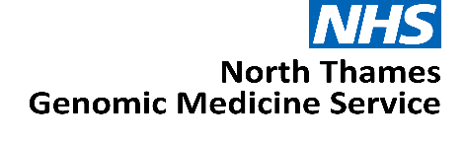

Expression of Interest:

Primary Care Genomics Lead

North Thames Genomic Medicine Service

JOB TITLE: Primary Care Genomics Lead

AREA/SPECIALITY: NHS North Thames Genomic Medicine Service (GMS)

GRADE: Dependent on applications

COMMITMENT: 3 x 1 PA (1/2 a day per week)

TENURE: Salary recharge agreement from 1st April 2026 until 31st March 2029

BASE: Continue to be employed at host organisation with option to work
from the GOSH site, travel may be required within the North Thames
geography

RESPONSIBLE TO: NT GMS Deputy Medical Director

ACCOUNTABLE TO: NT GMS Medical Director

Role Summary
We are seeking motivated and experienced Primary Care General Physicians to provide senior clinical leadership to embed genomic medicine into primary care and neighbourhood health services, supporting delivery of the Genomics Population Health Clinical Function and contributing to cancer and rare disease pathways whilst providing expertise and leadership in delivering education and training to the primary care workforce.

As key members of the North Thames Senior Delivery Team the postholders will lead the development of genomics-enabled models of care in primary and community settings, supporting risk identification, appropriate referral, cascade testing, pharmacogenomics and prevention-focused genomic interventions, in line with the NHS 10 Year Health Plan and the NHS GMS Service Specification.
Working 1 PA a week each, this is an exciting opportunity for GPs with relevant expertise to join the North Thames GMS.

Background

The NHS has a strong, long and pioneering history of using genetic medicine to help improve the lives of patients.
In 2018, the NHS England Genomics Unit set-out how it would achieve the forward-looking ambition to make England one of the first countries to incorporate genomics into routine clinical practice in our healthcare system. The solution, to create an opportunity for a step-change by launching a dedicated service – the Genomic Medicine Service (GMS).
The ambition was to make England one of the first countries to embed genomics into routine clinical care in a national healthcare system.
The establishment of the GMS aimed to bridge the gap between research and clinical care – shaping how genomics is advanced and applied within an NHS setting including for:
- Diagnostic testing
- Treatment decision
- Predictive testing
- Cancer testing
Through the GMS, 55 million people in England have access to consistent and fair genomic testing. The GMS is spilt into seven regional services, each region is responsible for delivering genomic testing, upskilling and educating the NHS workforce, participating in genomic research and working with the patient and public in re-designing clinical pathways across their population.
The NHS 10-Year Plan proposes a future where genomic or genetic interactions becomes part of routine healthcare, available to everyone in local communities playing a key part in the shift to Neighbourhood Health. This may include for example, screening all newborns to understand their future health needs or offering adults tests to spot the early signs of conditions like cancer or heart disease before symptoms appear. By identifying risks early, genomics can inform personalised treatments sooner and more effectively.
By 2035, NHS England estimate that up to half of all medical treatments or healthcare decisions will utilise genomics to improve patient care.
The North Thames Genomic Medicine Service

The North Thames Genomic Medicine Service (NT GMS) strives to provide an equitable genomic service for people living in North London and parts of Hertfordshire and Essex. We also provide cancer genomic testing for people living in Kingston, Merton, Richmond, Wandsworth and Sutton.
Across England the NT GMS is the second largest regional provider of genetic and genomic testing from the seven regions and delivers the largest volume of cancer genetic testing. The service also provides the largest portfolio of specialist rare and inherited disease genomic testing that is not provided by other GMS regions. We are also home to the only amyloidosis genetic testing facility in the UK.

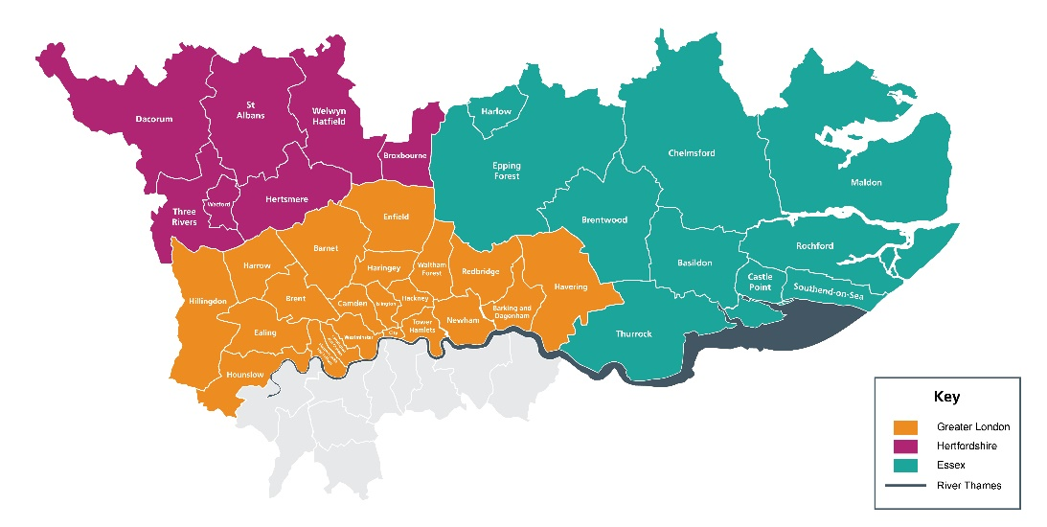

The NT GMS is a collaboration of multiple acute providers across North London. Hosted by Great Ormond Street Hospital NHS Foundation Trust (GOSH), led by GOSH and the Royal Marsden NHS Foundation Trust (RMH), the service brings together expertise from across the geography to deliver genomics services.
Our senior leadership team is led by Medical and Scientific Directors as well as a Chief Operating Officer and are supported by teams across cross-cutting laboratory and clinical workstreams. Our Patient, Public and Carer Panel feed into every aspect of the work in the NT GMS. Our strength across key areas: cancer, population health, rare and inherited disease, and research and innovation spans not only testing but clinical expertise and support from wider systems.

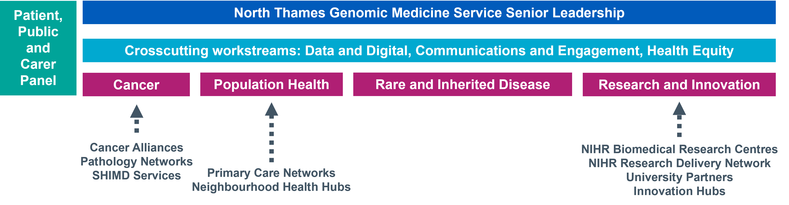
This expertise is spread across our geography, providing unique insights and local knowledge of not only specialist areas but also the population and community we serve. Through collaborations and knowledge sharing, we have built a team with expertise across all areas of genomics - from technology development, clinical integration, operational and programme management, education, social science, communications and engagement and health equity.
We believe our significant expertise puts us at the heart of delivering the genomics ambitions of the NHS and the 10 Year Plan that was published in 2025.
Main Roles & Responsibilities
Education, Training & Workforce Development
- To work closely with the NT GMS Education, Training and Workforce Lead to help develop a sustainable Education and Training strategy and delivery plan for the primary and community care workforce across the region.

- Support delivery and reporting of Education and Training workstreams, ensuring alignment with NT GMS priorities, national governance requirements, and the GMS contract specification.

- Support delivery of the Genomics Champion model within primary care, aligned to the national competency framework.

- Work with the national GMS Primary Care leads and the Genomics Education Programme to develop and implement local and nationally relevant training resources.

Population Health, Equity and Public Engagement
- Provide expertise to population-level initiatives in primary and community care services, pharmacogenomics and emerging polygenic risk score programmes.

- Support development of new population health genomic models of care in partnership with primary care and neighbourhood health teams.

- Working with the NT GMS Health Equity Lead, promote equitable access to genomic testing across communities, addressing variation and health inequalities.

- Work with the NT GMS Communications and Engagement lead on patient and public involvement projects as required.

Pathway Transformation, Service Improvement and Research
- Embed a programme of raising awareness of genomics across the primary and secondary care community services.

- Support development of new models of care, including standardised referral and follow-up pathways for genomic testing in primary care and work with the NT GMS Genomic Counsellor to support digital and remote future approaches to genomic counselling.

- Ensure primary care engagement with agreed consent models, documentation standards and data flows.

- Work closely with the NT GMS Informatics and Digital team to support the adoption of national digital services including:

- Order Management systems
- Unified Genomic Record

- Support primary care participation in genomics research and service evaluation initiatives, including national programmes where relevant.

- Promote research-ready pathways in primary care, ensuring appropriate consent and governance.

- Lead the development and implementation of primary-care-facing genomic pathways, i.e. family history assessment and cascade testing, inherited cancer and cardiovascular risk pathways that align with the National Genomic Test Directory.
Governance, Leadership and Stakeholder Engagement
- Attend relevant meetings as directed by the NT GMS Leadership Team, providing written or verbal updates as required.
- Represent the NT GMS at external regional and national meetings as required.

- Act as the link to the NT GMS and ensure effective communication across primary and community care networks at a regional and national level.

- Participate in any transformation programmes or service improvement projects in priority areas as agreed and contribute to the NT GMS annual delivery plan.

- Close working with colleagues and key stakeholders at all levels, including NT GMS leadership, all referring entities (NHS Trusts) across the region, the Genomics Education Programme (GEP), NHS England Genomics Unit and Genomics England.

Working relationships

Internal
- GMS Senior Management and Delivery teams
- Laboratory leads and staff across the GMS
- North Thames Clinical Genetics Services
- North Thames Patient and Public Involvement panel

External
- North Thames Trust boards, ICB’s & ICS’s across the GMS geography
- North Thames primary care networks
- NHS England Genomics Unit
- Public Health England
- Other Genomic Medicine Services across England
- North Thames mainstream clinical services
- North Thames Cancer Alliances

Person Specification

Criteria | Essential/Desirable | Assessment (Application/Interview)
Practicing general practitioner in the NHS registered with the GMC, with expertise/specialist interest in genomic medicine | E | Application
Understanding and knowledge of inherited condition and/or cancer genomics. | E | Application
Understanding of professional and current issues related to genetics and a commitment to mainstreaming genomics. | E | Application/Interview
Experience of building and developing strong and effective teams and providing robust and visible leadership in a range of public facing and challenging environments. | E | Application/Interview
Ability to establish and maintain working relationships with stakeholders | E | Application/Interview
Understanding of data governance, research ethics, consent models, and use of national research datasets | E | Application/Interview
Able to influence a large group of independent practitioners | E | Application/Interview
Evidence of participation in delivering education | E | Application/Interview
Satisfactory record of continuous professional development. | E | Application
Demonstrates good strategic awareness of wider NHS issues particularly for primary and community care and the implication of NHS drivers on these services. | E | Application/Interview
Evidence of excellent communication skills. | E | Application/Interview
Evidence of implementing transformation and service improvement programmes | D | Application/Interview

Terms and Conditions
These are 1 PA per week posts with line management and supervision reporting into the NT GMS Deputy Clinical Director. The duration for the post is until 31st March 2029
The applicants should be working for an employer within the North Thames GMS geography and will remain employed with their substantive employer for the duration of this role.
Health & Safety
Employees must be aware of the responsibilities placed upon them under the Health & Safety at Work Act (1974), to ensure that the agreed procedures are carried out to maintain a safe environment for employees and visitors.

Data Protection
Personal data is protected under the Data Protection Act (2018) and the post holder will ensure that it is securely held and that the requirements of the Act are followed.

Confidentiality
The confidentiality of information relating to patients/clients and staff must be safeguarded at all times in accordance with the Information Security Policy. Disclosure to any unauthorised person or misuse or failure to properly safeguard confidential data will be regarded as a disciplinary offence.

Expression of Interest Form
Please email the completed form below and CV to paul.ryves@gosh.nhs.uk with the subject heading: Primary Care Genomics Lead EOI

The deadline for submission is Wednesday 13th May
Interviews to be held Wednesday 20th May

- Applicant details
Name | Email address
Employer name | Job title

- Please tell us why you are interested in the Primary Care Genomics Lead role and the skills, experience and unique perspective you would bring to the team (maximum 1000 words).

- Finance
Please state your current AfC banding or current NHS salary
Applicant current agenda for change banding and/or NHS salary:

- Supporting statement from your senior manager
I can confirm my full support for the above applicant and agree to:
- Support the applicant to work within the role in the Genomic Medicine Service as described above
- Release the applicant from their current commitments for the proposed time

Name | Position
Telephone number | Email contact
Signature & Date

- Applicant CV
Please attach applicant CV (maximum of two pages) to the expression of interest submission.

