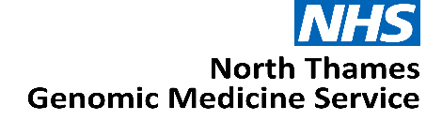

Expression of Interest:

Genomic Counsellor

North Thames Genomic Medicine Service

JOB TITLE: Genomic Counsellor

AREA/SPECIALITY: NHS North Thames Genomic Medicine Service

GRADE: B7

COMMITMENT: 0.4WTE (2 days per week – job share will be considered)

TENURE: Salary recharge agreement from 1st April 2026 until 31st March 2029

BASE: Continue to be employed at host organisation with option to work
from the GOSH site, travel maybe required within the North Thames
geography

RESPONSIBLE TO: NT GMS Clinical Genetic Consultant

ACCOUNTABLE TO: NT GMS Deputy Medical Director

Role Summary

We are seeking an experienced Genomic Counsellor with a strong interest in education, service development, and population-level genomics. The successful candidate will bring clinical credibility, a patient-centred approach, and a commitment to equity to help shape the delivery of genomics across North Thames.

This role provides genomic counselling input to support delivery of the Rare Disease, Cancer and Population Health clinical functions within the new Genomic Medicine Service (GMS) specification, aligned to the NHS 10-Year Health Plan.

As a key member of the North Thames GMS Senior Delivery Team, the postholder will work closely with the Senior Leadership Team to provide genomic counselling input into genomic mainstreaming across rare disease and cancer pathways, drive pathway improvement, and support equitable uptake of genomic testing across the region.

Working two days per week, this is an exciting opportunity to influence education and training across acute and primary care services, embed genomics into clinical pathways, and continually improve access to high-quality genetic testing for patients and their families.

Background

The NHS has a strong, long and pioneering history of using genetic medicine to help improve the lives of patients.
In 2018, the NHS England Genomics Unit set-out how it would achieve the forward-looking ambition to make England one of the first countries to incorporate genomics into routine clinical practice in our healthcare system. The solution, to create an opportunity for a step-change by launching a dedicated service – the Genomic Medicine Service (GMS).
The ambition was to make England one of the first countries to embed genomics into routine clinical care in a national healthcare system.
The establishment of the GMS aimed to bridge the gap between research and clinical care – shaping how genomics is advanced and applied within an NHS setting including for:
- Diagnostic testing
- Treatment decision
- Predictive testing
- Cancer testing
Through the GMS, 55 million people in England have access to consistent and fair genomic testing. The GMS is spilt into seven regional services, each region is responsible for delivering genomic testing, upskilling and educating the NHS workforce, participating in genomic research and working with the patient and public in re-designing clinical pathways across their population.
The NHS 10-Year Plan proposes a future where genomic or genetic interactions becomes part of routine healthcare, available to everyone in local communities playing a key part in the shift to Neighbourhood Health. This may include for example, screening all newborns to understand their future health needs or offering adults tests to spot the early signs of conditions like cancer or heart disease before symptoms appear. By identifying risks early, genomics can inform personalised treatments sooner and more effectively.
By 2035, NHS England estimate that up to half of all medical treatments or healthcare decisions will utilise genomics to improve patient care.

The North Thames Genomic Medicine Service

The North Thames Genomic Medicine Service (NT GMS) strives to provide an equitable genomic service for people living in North London and parts of Hertfordshire and Essex. We also provide cancer genomic testing for people living in Kingston, Merton, Richmond, Wandsworth and Sutton.
Across England the NT GMS is the second largest regional provider of genetic and genomic testing from the seven regions and delivers the largest volume of cancer genetic testing. The service also provides the largest portfolio of specialist rare and inherited disease genomic testing that is not provided by other GMS regions. We are also home to the only amyloidosis genetic testing facility in the UK.

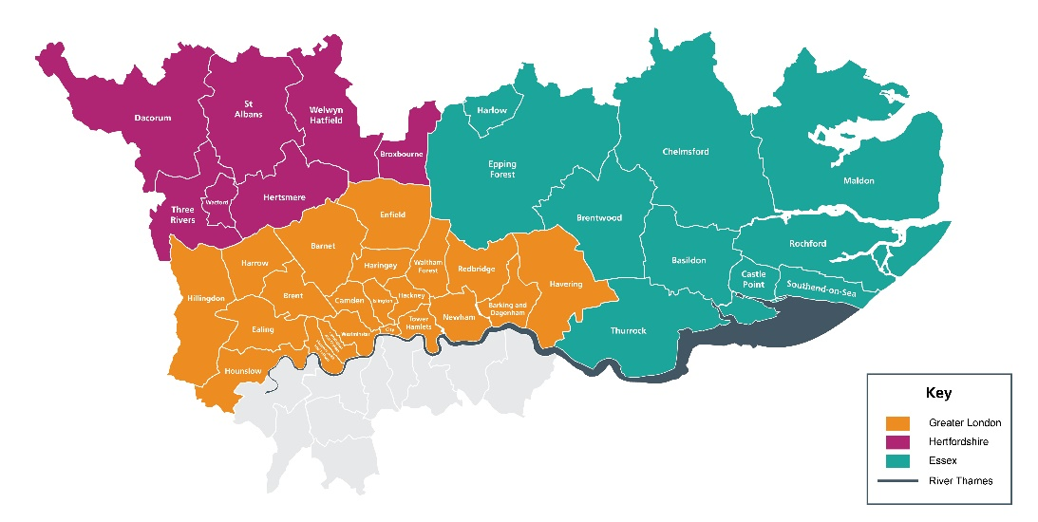

The NT GMS is a collaboration of multiple acute providers across North London. Hosted by Great Ormond Street Hospital NHS Foundation Trust (GOSH), led by GOSH and the Royal Marsden NHS Foundation Trust (RMH), the service brings together expertise from across the geography to deliver genomics services.
Our senior leadership team is led by Medical and Scientific Directors as well as a Chief Operating Officer and are supported by teams across cross-cutting laboratory and clinical workstreams. Our Patient, Public and Carer Panel feed into every aspect of the work in the NT GMS. Our strength across key areas: cancer, population health, rare and inherited disease, and research and innovation spans not only testing but clinical expertise and support from wider systems.

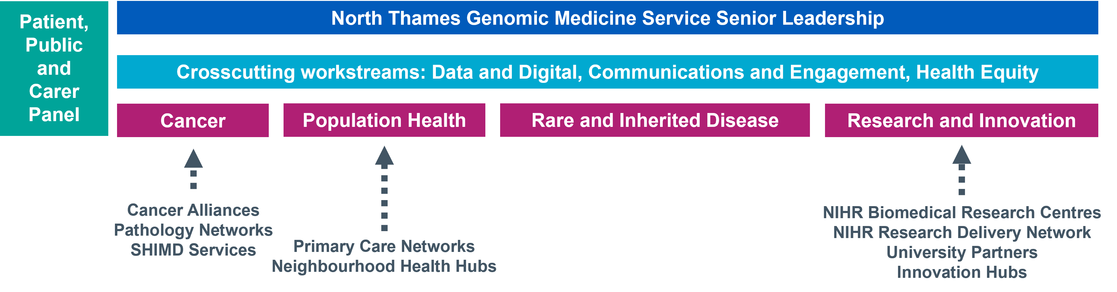

This expertise is spread across our geography, providing unique insights and local knowledge of not only specialist areas but also the population and community we serve. Through collaborations and knowledge sharing, we have built a team with expertise across all areas of genomics - from technology development, clinical integration, operational and programme management, education, social science, communications and engagement and health equity.
We believe our significant expertise puts us at the heart of delivering the genomics ambitions of the NHS and the 10 Year Plan that was published in 2025.
Main Roles & Responsibilities
Education, Training and Workforce Development
- Work closely with the NT GMS Education, Training and Workforce Lead to develop and deliver a sustainable education and training strategy for the current and future multi-professional workforce across the region.

- Support delivery and reporting of Education and Training workstreams, ensuring alignment with NT GMS priorities, national governance requirements, and the GMS contract specification.

- Deliver training and upskilling to clinicians, nursing and midwifery workforce across the geography, including in primary and community care.

Clinical Pathways and Service Integration
- Raise awareness of genomic services across multidisciplinary teams and support pathway-based approaches to embedding genomics into patient journeys.

- Identify opportunities for and participate in service improvement and pathway transformation.

- Work across multiple specialties to promote consistent genomic test requesting and adoption of the ‘Right Test at the Right Time’ approach and supporting demand management across the region.

Population Health, Equity and Public Engagement
- Provide genomic counselling expertise to population-level genomic initiatives, including cascade testing, inherited cancer and cardiac pathways, pharmacogenomics, and emerging polygenic risk score programmes.

- Support the development of Genomics Champions within neighbourhood teams.

- Work with the NT GMS Health Equity Lead to understand and address variation and unmet need in access to genomic testing.

- Collaborate with the Communications and Engagement Lead on patient and public involvement initiatives as required.

Governance, Leadership and Stakeholder Engagement
- Attend relevant meetings as directed by the NT GMS Leadership Team, providing written or verbal updates as required.

- Act as a key link between North Thames Genomic Counselling services and the NT GMS, ensuring close alignment in delivery of clinical genomic functions.

- Represent the NT GMS at regional and national meetings when appropriate.

- Work closely with key stakeholders across all levels, including NT GMS leadership, NHS Trusts across the region, the Genomics Education Programme (GEP), NHS England Genomics Unit, and Genomics England.

Working relationships

Internal
- GMS Senior Management and Delivery teams
- Laboratory leads and staff across the GMS
- North Thames Clinical Genetics Services
- GMS Clinical Genetics Leads
- North Thames Patient and Public Involvement panel

External
- North Thames Trust boards, ICB’s & ICS’s across the GMS geography
- NHS England Genomics Unit
- Public Health England
- Other Genomic Medicine Services across England
- North Thames mainstream clinical services
- North Thames Cancer Alliances
- Cancer Charities and Advocacy Services

Person Specification
Academic/Professional qualification/Training | Essential | Desirable | Assessment method
First degree in relevant subject and MSc in Genetic Counselling and AHCS registered  OR  Graduate Nurse or Midwife with two years post-registration experience plus counselling skills training of at least 120 hours and an accredited genetics science course of at least 30 hours and AHCS registered  OR  Completed an STP in Genomic Counselling and registered with HCPC | E |  | I/A
Registered Genetic Counsellor with AHCS  OR  Registered Genetic Counsellor (clinical scientist) with the HCPC  OR  Registered with an overseas body which has a reciprocity agreement in place with the AHCS and be willing to commit to register within an agreed timeframe. | E |  | I/A
Is an approved AHCS Sign Off Mentor |  | D | A
Experience/Knowledge
Understanding of professional and current issues related to genetics, the NHS, and relevant fields | E |  | A/I
Understanding of audit and research methodologies | E |  | A/I
Familiarity with databases, powerpoint and word processing | E |  | A/I
Minimum 2 year’s experience in genetic counselling |  | D | A/I
Experience of dealing with families with genetic disorders | E |  | A/I
Understanding of educational methodologies and learning styles | E |  | A/I
Working with people who are distressed | E |  | A/I
Previous experience of research and audit | E |  | A/I
Understanding of resource management, health and safety and clinical governance | E |  | A/I
Knowledge and awareness of safeguarding procedures | E |  | A/I
Works within AGNC code of ethics and GCRB/AHCS code of conduct | E |  | A/I
Skills/Abilities
Ability to work autonomously and manage workload | E |  | A/I
Ability to work within a multidisciplinary team | E |  | A/I
Excellent organisational skills | E |  | A/I
Excellent verbal and written communication and listening skills | E |  | I
Able to problem solve and initiate change | E |  | A/I
Self-discipline and good time management to support periods of  lone working | E |  | A/I
Ability to analyse research findings to inform practice development |  | D | A/I
Maintain Registration with AHCS | E |  | A/I
Excellent presentation skills and ability to adapt to needs of the audience | E |  | A/I
Ability and willingness to travel to across North Thames Region | E |  | A/I
Flexible approach working arrangements, where possible, to support service needs | E |  | A/I

Terms and Conditions
This is a 2 day per week post with line management and supervision reporting into the NT GMS Deputy Medical Director. The duration for the post is until 31st March 2029
The applicant should be working for an employer within the North Thames GMS geography and will remain employed with their substantive employer for the duration of this role.

Health & Safety
Employees must be aware of the responsibilities placed upon them under the Health & Safety at Work Act (1974), to ensure that the agreed procedures are carried out to maintain a safe environment for employees and visitors.

Data Protection
Personal data is protected under the Data Protection Act (2018) and the post holder will ensure that it is securely held and that the requirements of the Act are followed.

Confidentiality
The confidentiality of information relating to patients/clients and staff must be safeguarded at all times in accordance with the Information Security Policy. Disclosure to any unauthorised person or misuse or failure to properly safeguard confidential data will be regarded as a disciplinary offence.

Expression of Interest Form
Please email the completed form below and CV to paul.ryves@gosh.nhs.uk with the subject heading: Genomic Counsellor EOI

The deadline for submission is Wednesday 13th May
Interview date: Wednesday 20th May

- Applicant details
Name | Email address
Employer name | Job title

- Please tell us why you are interested in the Genomic Counsellor role and the skills, experience and unique perspective you would bring to the team (maximum 1000 words).

- Finance
Please state your current AfC banding or current NHS salary
Applicant current agenda for change banding and/or NHS salary:

- Supporting statement from your senior manager
I can confirm my full support for the above applicant and agree to:
- Support the applicant to work within the role in the Genomic Medicine Service as described above
- Release the applicant from their current commitments for the proposed time

Name | Position
Telephone number | Email contact
Signature & Date

- Applicant CV
Please attach applicant CV (maximum of two pages) to the expression of interest submission.

