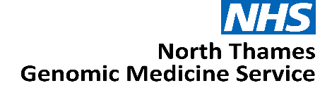

Expression of Interest:

Clinical Consultant Pharmacist Lead

North Thames Genomic Medicine Service

JOB TITLE: Clinical Consultant Pharmacist Lead

AREA/SPECIALITY: NHS North Thames Genomic Medicine Service (GMS)

GRADE: 8C

COMMITMENT: 0.8WTE (4 days per week)

TENURE: Salary recharge agreement from 1st April 2026 until 31st March 2029

BASE: Continue to be employed at host organisation with option to work
from the GOSH site, travel maybe required within the North Thames
geography

RESPONSIBLE TO: NT GMS Chief Pharmacist

ACCOUNTABLE TO: NT GMS Medical Director

Role Summary
We are seeking a motivated and experienced Pharmacist to provide senior professional leadership for pharmacy. The primary focus will be to help deliver the objectives of the Cancer Genomics and Population Health clinical functions in the new Genomic Medicine Service specification, supporting the NHS 10 Year Health Plan ambitions.

As a key member of the North Thames Senior Delivery Team, the postholder will work with the Senior Leadership Team to ensure genomic test results are consistently and safely translated into medicines optimisation, access to targeted therapies, clinical trials, and pharmacogenomic-informed prescribing.

The role will provide expertise and leadership in supporting and delivering education and training to the pharmacy workforce, help drive pathway improvements and equitable uptake of pharmacogenomic testing across the region.
Working four days a week, this is an exciting opportunity for a pharmacist with relevant expertise to join the North Thames GMS.

Background

The NHS has a strong, long and pioneering history of using genetic medicine to help improve the lives of patients.
In 2018, the NHS England Genomics Unit set-out how it would achieve the forward-looking ambition to make England one of the first countries to incorporate genomics into routine clinical practice in our healthcare system. The solution, to create an opportunity for a step-change by launching a dedicated service – the Genomic Medicine Service (GMS).
The ambition was to make England one of the first countries to embed genomics into routine clinical care in a national healthcare system.
The establishment of the GMS aimed to bridge the gap between research and clinical care – shaping how genomics is advanced and applied within an NHS setting including for:
- Diagnostic testing
- Treatment decision
- Predictive testing
- Cancer testing
Through the GMS, 55 million people in England have access to consistent and fair genomic testing. The GMS is spilt into seven regional services, each region is responsible for delivering genomic testing, upskilling and educating the NHS workforce, participating in genomic research and working with the patient and public in re-designing clinical pathways across their population.
The NHS 10-Year Plan proposes a future where genomic or genetic interactions becomes part of routine healthcare, available to everyone in local communities playing a key part in the shift to Neighbourhood Health. This may include for example, screening all newborns to understand their future health needs or offering adults tests to spot the early signs of conditions like cancer or heart disease before symptoms appear. By identifying risks early, genomics can inform personalised treatments sooner and more effectively.
By 2035, NHS England estimate that up to half of all medical treatments or healthcare decisions will utilise genomics to improve patient care.
The North Thames Genomic Medicine Service

The North Thames Genomic Medicine Service (NT GMS) strives to provide an equitable genomic service for people living in North London and parts of Hertfordshire and Essex. We also provide cancer genomic testing for people living in Kingston, Merton, Richmond, Wandsworth and Sutton.
Across England the NT GMS is the second largest regional provider of genetic and genomic testing from the seven regions and delivers the largest volume of cancer genetic testing. The service also provides the largest portfolio of specialist rare and inherited disease genomic testing that is not provided by other GMS regions. We are also home to the only amyloidosis genetic testing facility in the UK.

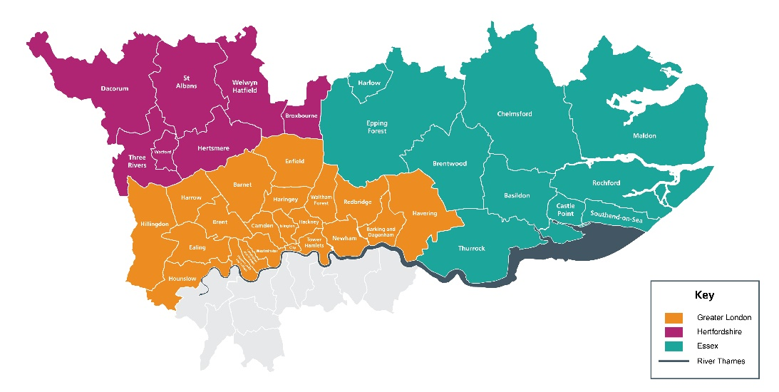

The NT GMS is a collaboration of multiple acute providers across North London. Hosted by Great Ormond Street Hospital NHS Foundation Trust (GOSH), led by GOSH and the Royal Marsden NHS Foundation Trust (RMH), the service brings together expertise from across the geography to deliver genomics services.
Our senior leadership team is led by Medical and Scientific Directors as well as a Chief Operating Officer and are supported by teams across cross-cutting laboratory and clinical workstreams. Our Patient, Public and Carer Panel feed into every aspect of the work in the NT GMS. Our strength across key areas: cancer, population health, rare and inherited disease, and research and innovation spans not only testing but clinical expertise and support from wider systems.

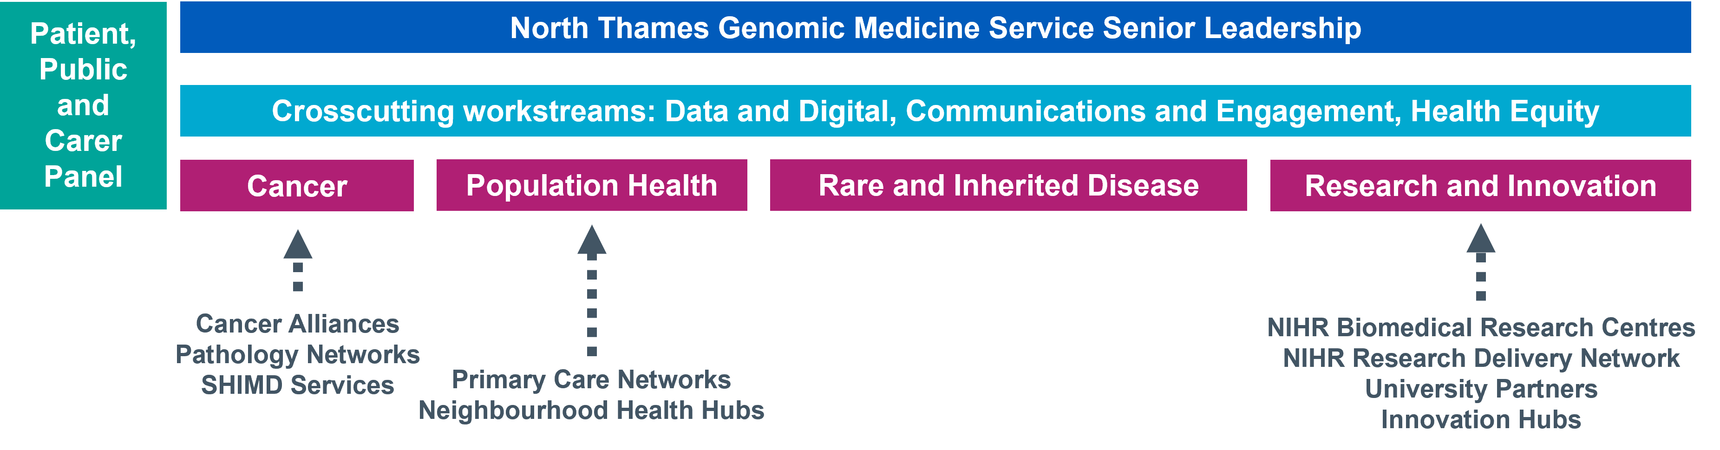
This expertise is spread across our geography, providing unique insights and local knowledge of not only specialist areas but also the population and community we serve. Through collaborations and knowledge sharing, we have built a team with expertise across all areas of genomics - from technology development, clinical integration, operational and programme management, education, social science, communications and engagement and health equity.
We believe our significant expertise puts us at the heart of delivering the genomics ambitions of the NHS and the 10 Year Plan that was published in 2025.
Main Roles & Responsibilities
Education, Training & Workforce Development
- To work closely with the NT GMS Education, Training and Workforce Lead to help develop a sustainable Education and Training strategy and delivery plan for the Pharmacy workforce - current and future - across the geography.

- Support delivery and reporting of Education and Training workstreams, ensuring alignment with NT GMS priorities, national governance requirements, and the GMS contract specification.

- To be involved in the development of higher education qualifications, thereby contributing to national education policy.

Clinical Integration, Pathway and Service Improvement
- Raise awareness of genomic services across the Pharmacy community in tertiary, secondary and primary care services, supporting the embedding of pharmacy input into end-to-end cancer genomic pathways, from test selection through to prescribing and monitoring.

- Support the managed introduction and implementation of new precision medicines and associated genomic tests, including providing input to national and regional medicines optimisation committees or other relevant governance committees.

- Review current activity in terms of pharmacogenomic testing across the NT GMS region and opportunities to develop the role of the pharmacist within pharmacogenomic pathways.

- Support the NT testing laboratories in delivering responsive and increasingly pre-emptive pharmacogenomic testing across the geography.

- Consider personalised medicine beyond pharmacogenomics – other targeted treatments, gene therapies, histology-independent drugs etc – and where pharmacy input would be beneficial.

- Lead, support and contribute to research in pharmacogenomics and/or precision medicine, including clinical outcomes.

- Support the Senior Leadership and Delivery teams by providing pharmacy advice when necessary, in the ongoing delivery of Cancer Genomic Tumour Advisory Boards / Molecular Tumour Boards.

- Work closely with the NT GMS Informatics and Digital team to ensure medicines-related outputs are visible in:
- Electronic patient records
- Unified Genomic Record
- Order Management and reporting systems
- To lead on and participate in clinical audits, quality improvement projects and development and implementation of treatment protocols and guidelines for use of medicines within Genomic Medicine, using quality improvement skills and methodology where required

Population Health, Equity and Public Engagement
- Provide pharmacy expertise to population-level initiatives in pharmacogenomics and emerging polygenic risk score programmes.

- Support development of new population health genomic models of care in partnership with primary care and neighbourhood health teams.

- Working with the NT GMS Health Equity Lead, help understand and address unmet need and variation in equity of access to pharmacogenomic testing across the NT GMS geography.

- Work with the NT GMS Communications and Engagement lead on patient and public involvement projects as required.

Governance, Leadership and Stakeholder Engagement
- Attend relevant meetings as directed by the NT GMS Leadership Team, providing written or verbal updates as required.
- Represent the NT GMS at external regional and national meetings as required.

- Act as the link to the NT GMS and ensure effective communication across pharmacy and other networks at a regional and national level.

- Participate in any transformation programmes or service improvement projects in priority areas as agreed and contribute to the NT GMS annual delivery plan.

- Close working with colleagues and key stakeholders at all levels, including NT GMS leadership, all referring entities (NHS Trusts) across the region, the Genomics Education Programme (GEP), NHS England Genomics Unit and Genomics England.

Working relationships

Internal
- GMS Senior Management and Delivery teams
- Laboratory leads and staff across the GMS
- North Thames Clinical Genetics Services
- North Thames Patient and Public Involvement panel

External
- North Thames Trust boards, ICB’s & ICS’s across the GMS geography
- North Thames and National pharmacy networks
- NHS England Genomics Unit
- Public Health England
- Other Genomic Medicine Services across England
- North Thames mainstream clinical services
- North Thames Cancer Alliances
- Cancer Charities and Advocacy Services

Person Specification

Criteria | Essential or Desirable | Assessment method (Application/Interview)
Education and qualifications
BPharm/MPharm degree | E | Application
Postgraduate Diploma in clinical pharmacy or equivalent | E | Application
Registered as a pharmacist with the General Pharmaceutical Council | E | Application
Post Graduate qualification in Genomics (ongoing or completed) or equivalent clinical experience in genomics | D | Application
Formal teaching training | D | Application
Doctoral qualification or undertaking study at doctorate level | D | Application
Membership of the Royal Pharmaceutical Society | E | Application
Occupational experience and abilities
Demonstrable commitment to improving the quality of patient care using a whole system patient focused approach | E | Application/Interview
High level of clinical experience and expertise at consultant pharmacist level, or working towards credentialling | E | Application/Interview
Proven experience of working at a strategic level with senior clinicians and managers | E | Application/Interview
Appropriate and current clinical experience in Pharmacogenomics or related field | E | Application/Interview
Experience in working at a regional/national level (e.g. as member of committee or via presentations/academic publications) | E | Application/Interview
A majority of competencies in each of the following - expert professional practice, building working relationships and leadership clusters at the highest level (mastery) as defined in the Department of Health guidance for Consultant Pharmacists | D | Application
A majority of the competencies in each of the management, education, training and development and research and evaluation clusters at the intermediate level (excellence) as defined in the Department of Health guidance for Consultant Pharmacists | D | Application
Project leadership skills in highly  complex projects | D | Application/Interview
Proven experience of working at a strategic level across the wider health community | D | Application/Interview
Knowledge and skills
Understanding of professional and current issues related to genetics, the NHS, and relevant fields | E | Application/Interview
Ability to operate at inter/intra agency level and engage partners across boundaries | E | Application/Interview
Proven ability to work within a varied and complex, networked working environment | E | Application/Interview
Ability to establish and maintain working relationships with external stakeholders | E | Application/Interview
Experienced at undertaking change management | E | Application/Interview
Able to interpret highly complex data and present highly complex information in an informative manner to a wide range of individuals | E | Application/Interview
Understanding of NHS structure, systems and politics | E | Application/Interview
Excellent managerial, leadership and organisational skills | E | Application/Interview
Ability to work without close supervision, providing specialist advice to the organisation | E | Application/Interview
Relevant publications in peer reviewed journals | E | Application/Interview
Knowledge of pharmacogenomics | E | Application/Interview
Education and training skills with Higher Education Institution(s) | E | Application/Interview
Report and business case writing for a Board level audience | D | Application/Interview
Sound understanding of political agendas and able to work successfully in a political environment | D | Application/Interview
Personal qualities
Persuasive, excellent communicator | E | Interview
Professional and personal integrity | E | Interview
Enthusiasm and self-motivation | E | Interview
Assertive and inspires confidence | E | Interview
Team player but also able to work  autonomously | E | Interview
Able to influence a large group of  independent practitioners | E | Interview

Terms and Conditions
This is a 4 day per week post with line management and supervision reporting into the NT Chief Pharmacist. The duration for the post is until 31st March 2029
The applicant should be working for an employer within the North Thames GMS geography and will remain employed with their substantive employer for the duration of this role.
Health & Safety
Employees must be aware of the responsibilities placed upon them under the Health & Safety at Work Act (1974), to ensure that the agreed procedures are carried out to maintain a safe environment for employees and visitors.

Data Protection
Personal data is protected under the Data Protection Act (2018) and the post holder will ensure that it is securely held and that the requirements of the Act are followed.

Confidentiality
The confidentiality of information relating to patients/clients and staff must be safeguarded at all times in accordance with the Information Security Policy. Disclosure to any unauthorised person or misuse or failure to properly safeguard confidential data will be regarded as a disciplinary offence.

Expression of Interest Form
Please email the completed form below and CV to paul.ryves@gosh.nhs.uk with the subject heading: Clinical Consultant Pharmacist Lead EOI

The deadline for submission is Wednesday 13th May 2026
Interview date will be Wednesday 20th May 2026

- Applicant details
Name | Email address
Employer name | Job title

- Please tell us why you are interested in the Clinical Consultant Pharmacist Lead role and the skills, experience and unique perspective you would bring to the team (maximum 1000 words).

- Finance
Please state your current AfC banding or current NHS salary
Applicant current agenda for change banding and/or NHS salary:

- Supporting statement from your senior manager
I can confirm my full support for the above applicant and agree to:
- Support the applicant to work within the role in the Genomic Medicine Service as described above
- Release the applicant from their current commitments for the proposed time

Name | Position
Telephone number | Email contact
Signature & Date

- Applicant CV
Please attach applicant CV (maximum of two pages) to the expression of interest submission.

