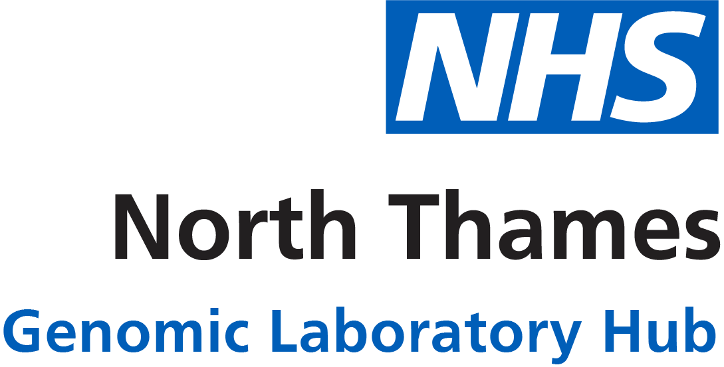

Pro forma for Cases to be submitted for Cancer Whole-Genome Sequencing (WGS) under the Acute leukaemia / ‘exhausted all Standard of care (ESOC)’ pipelines.

Genomic testing is commissioned by NHS England with the patients eligible to access a test specified in the national genomic test directory (NHS England » National genomic test directory).

NHS England have changed the eligibility criteria for Cancer WGS referrals. This criterion only applies to adults over the age of 26 and excludes CNS Tumours.

To accept submissions for solid and haematological tumour cases under the new criteria, we require the completion of the details below in addition to the information provided via the ROD and TOF. Please note that incomplete or lacking forms will delay the submission of these cases and that the lab will not actively chase missing information.

Paediatric and TYA patients, as well as CNS Tumours, can be referred without the completion of this pro forma.

- Disease entity/Pathway (i.e. AML, ALL, ESOC):

- G-banding/karyotype:

- DNA NGS:

- RNA Fusion NGS:

- Specific question/Issue to be address by WGS:

Please contact gos-tr.pmu@nhs.net with queries on how to submit/organisational queries.
Please get in touch with dortewren@nhs.net to discuss eligibility in further detail for specific cases.

